35 Things Your Employer Cannot Do: UNFAIR LABOR PRACTICE – (SECTION 8- NRLA)
1. Attend any union meeting, park across the street from the hall or engage in any undercover activity which would indicate that the employees are being kept under surveillance to determine who is and who is not participating in the union program.
2. Tell employees that the company will fire or punish them if they engage in union activity.
3. Lay off, discharge, discipline any employee for union activity.
4. Grant employees wage increases, special concessions, or benefits in order to keep the union out.
5. Bar employee-union representatives from soliciting employees’ memberships on or off the company property during non-working hours.
6. Ask employees about union matters, meetings, etc. (Some employees may, of their own accord, walk up and tell of such matters. It is not an unfair labor practice to listen, but to ask questions to obtain additional information is illegal).
7. Ask employees what they think about the union or a union representative once the employee refuses to discuss it.
8. Ask employees how they intend to vote.
9. Threaten employees with reprisal for participating in union activities. For example, threaten to move the plant or close the business, curtail operations or reduce employees’ benefits.
10. Promise benefits to employees if they reject the union.
11. Give financial support or other assistance to a union.
12. Announce that the company will not deal with the union.
13. Threaten to close, in fact close, or move plant in order to avoid dealing with a union.
14. Ask employees whether or not they belong to a union, or have signed up for union representation.
15. Ask an employee, during the hiring interview, about his affiliation with a labor organization or how he feels about unions.
16. Make anti-union statements or act in a way that might show preference for a non-union man.
17. Make distinctions between union and non-union employees when signing overtime work or desirable work.
18. Purposely team up non-union men and keep them apart from those supporting the union.
19. Transfer workers on the basis of union affiliations or activities.
20. Choose employees to be laid off in order to weaken the union’s strength or discourage membership in the union.
21. Discriminate against union people when disciplining employees.
22. By nature of work assignments, create conditions intended to get rid of an employee because of his union activity.
23. Fail to grant a scheduled benefit or wage increase because of union activity.
24. Deviate from company policy for the purpose of getting rid of a union supporter.
25. Take action that adversely affects an employee’s job or pay rate because of union activity.
26. Threaten workers or coerce them in an attempt to influence their vote.
27. Threaten a union member through a third party.
28. Promise employees a reward or future benefit if they decide “no union”.
29. Tell employees overtime work (and premium pay) will be discontinued if the plant is unionized.
30. Say unionization will force the company to lay off employees.
31. Say unionization will do away with vacations or other benefits and privileges presently in effect.
32. Promise employees promotions, raises or other benefits if they get out of the union or refrain from joining the union.
33. Start a petition or circular against the union or encourage or take part in its circulation if started by employees.
34. Urge employees to try to induce others to oppose the union or keep out of it.
35. Visit the homes of employees to urge them to reject the union.

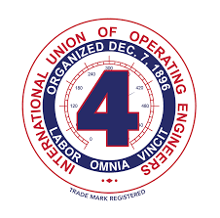
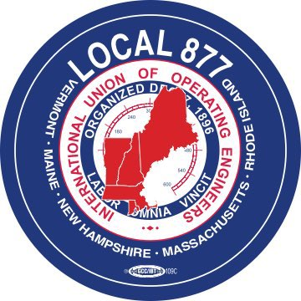

International Union of Operating Engineers (IUOE)

400,000 Members in Maintenance and Operation of Equipment

7 Covanta Plants Currently Under CBA with IUOE – 230+ Members

PA- Plymouth (542)

NJ- Camden (68)

NY- Babylon, Huntingdon, MacArthur (30)

CT- Bristol (30)

OR- Marion (701)

Your Right to Form a Union
If a majority of workers wants to form a union, they can select a union in one of two ways: If at least 30% of workers sign cards or a petition saying they want a union, the NLRB will conduct an election. If a majority of those who vote choose the union, the NLRB will certify the union as your representative for collective bargaining. An election is not the only way a union can become your representative. Your employer may voluntarily recognize a union based on evidence - typically signed union-authorization cards - that a majority of employees want it to represent them. Once a union has been certified or recognized, the employer is required to bargain over your terms and conditions of employment with your union representative. Special rules apply in the construction industry.

Your Rights during Union Organizing
You have the right to organize a union to negotiate with your employer over your terms and conditions of employment. This includes your right to distribute union literature, wear union buttons t-shirts, or other insignia (except in unusual "special circumstances"), solicit coworkers to sign union authorization cards, and discuss the union with coworkers. You can't be fired, disciplined, demoted, or penalized in any way for engaging in these activities.
Working time is for work, so your employer may maintain and enforce non-discriminatory rules limiting solicitation and distribution, except that your employer cannot prohibit you from talking about or soliciting for a union during non-work time, such as before or after work or during break times; or from distributing union literature during non-work time, in non-work areas, such as parking lots or break rooms. Also, restrictions on your efforts to communicate with co-workers cannot be discriminatory. For example, your employer cannot prohibit you from talking about the union during working time if it permits you to talk about other non-work-related matters during working time.

